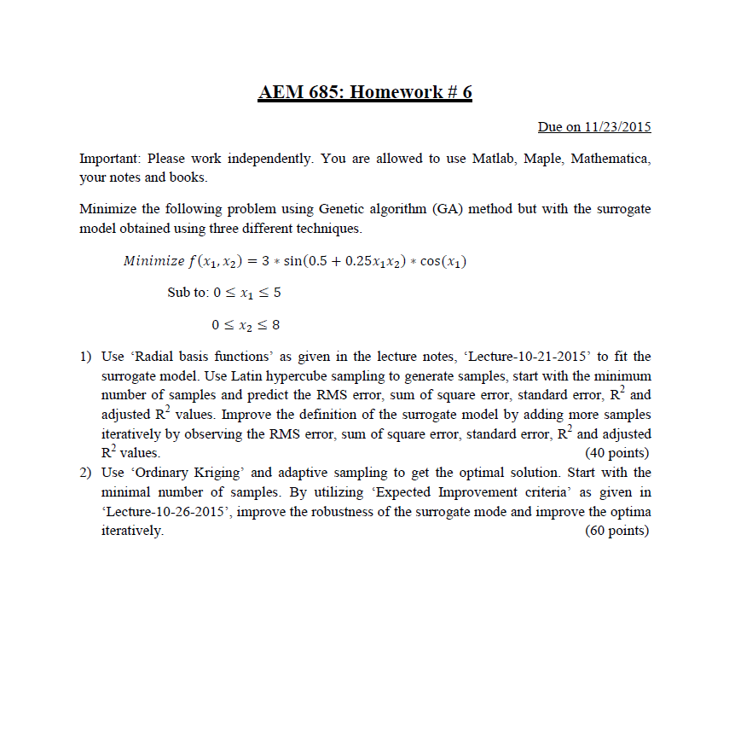



1)RDF

Initial LHS:



Loop=0  


For Elitist Strategy , Select all the good instead of adding one good spot, Loop=1



Loop=3,Tol=0.1, Fmin = -2.9127 End



Code:

%HW6_1

%Radial basis function

%LHS 16 samples

x = lhsdesign(16,2)%16 samples 2 varaibles

X=[x(:,1)*5 x(:,2)*8]

tol=0.1

for i=1:16

Y(i,1)= 3*sin(0.5+0.25*X(i,1)*X(i,2))*cos(X(i,1))

end

% create a neural network

net = newrb(X',Y')

%initial 16 parents

p=16;%number of parents

ns=16;%number of designs

c=5;%not -3

Sumf=0;%initial sum of fitness

loop=0;

Frank=[0;0];

%initial X

X=X';

f = @(x) 3*sin(0.5+0.25*x(1)*x(2))*cos(x(1));

while (1)

% create a neural network

for i=1:16

Y(i,1)= 3*sin(0.5+0.25*X(1,i)*X(2,i))*cos(X(1,i))

end

net = newrb(X,Y')

Sumf=0;

for (i=1:p)

F(i)=sim(net,[X(1,i);X(2,i)]);%calculating n(x)

Fs(i)=c-F(i);%minimization fitness

Sumf=Sumf+Fs(i);

i=i+1;

end

%rank based selection

% end of GA situation

for (i=1:p)

rank=p;

for (j=1:p)

if Fs(i)<Fs(j)

rank=rank-1;

end

j=j+1;

end

Frank(1,i)=rank;

Frank(2,i)=Fs(i);%Frank is with X

i=i+1;

end

%%%%%%%%%%%%%%%%%%%%%%%%%

if loop<=80

r=Fs/Sumf;%5.4.7

else

for(i=1:p)

r(i)=2*(ns-i+1)/((ns+1)*ns);%5.4.11

end

end

Ran=rand(1,p);%p random fall

Rf(1)=0;%wheel initialize

for (i=2:p+1)

Rf(i)=Rf(i-1)+r(i-1);

i=i+1;

end

%normal parrent choosing

for (i=1:p)

ii=1;

while ii<=p

if Ran(i)<Rf(ii+1)

Ran1(i)=ii;

ii=p+15;

else

ii=ii+1;

end

end

i=i+1;

end

%special transfer for ranking fitness

%if loop>80%same

for (i=1:p)

for (j=1:p)

if Ran1(i)==Frank(1,j)

Ran1(i)=j;%Ran1 is erased

end

j=j+1;

end

i=i+1;

end

%end

X=(X+5)*51.1%DEC to BIN

%binary lenth 9 (x+5)*51.1=new x for dec2bin

k=randi([1,8]);%random string length

%mutation

for i=1:p-1

sq1=Ran1(i);

sq2=Ran1(i+1);

[C(:,i),C(:,i+1)]=Mute(X(:,sq1),X(:,sq2),k);

i=i+2;

end

%Elitist Strategy

T=[X C];

T=(T/51.1)-5;%back to dec

for i=1:2*p

for j=i:2*p

if sim(net,[T(1,i);T(2,i)])>sim(net,[T(1,j);T(2,j)])

TV=T(:,j);

T(:,j)=T(:,i);

T(:,i)=TV;

end

j=j+1;

end

i=i+1;

end

X=T(:,1:p);

plot(X(1,:),X(2,:),'o')%PLOTING

hold on

if abs(f(X(:,1))+3)<tol

break

end

loop=loop+1;

end

Fmin=f(X(:,1))%the min f

X(:,1)

plot(X(1,2),X(2,2),'*')

hold on

loop

x1=linspace(0,5,16);

x2=linspace(0,8,16);

[XF1,XF2]= meshgrid(x1,x2)

for i=1:16

for j=1:16

N(i,j)=sim(net,[XF1(i,j);XF2(i,j)]);

end

end

contour(XF1,XF2,N)

title('RDF','FontWeight','bold','FontSize',20,'FontName','Times New Roman');

xlabel('X_1','FontWeight','bold','FontSize',12,'FontName','Times New Roman');

ylabel('X_2','FontWeight','bold','FontSize',12,'FontName','Times New Roman');

hold on

axis([0 5 0 8])